Oct7 HK trading

**954**

Short @ 9995, stop @ 10035

Why? Shorting on the way up.

Potentially weakness: might be too early (noon: yes, it was too early)

MAE: 34 (10029) (noon: MAE: 197) (close: MAE: 405)

If you let your emotion follow the tick, it is already a loss, need to determine the exit beforehand. How to determine exit position is quite important.

**1000**

Stop loss was hit, filled @ 10035 (loss was 400). Wait for 1 hour.

Reflect on entrance methodology + stop loss check.

**1006**

這個點鐘還沒有消耗掉雙方的力量。Wait until energy is consumed on both sides. (noon: the buyer’s force is clearly stronger than the sellers, as seen around 11am when the market was trying to sell, it lingered and quickly bounded back)

In the long term, position trading will prevail over trend following. (correct, but you want to limit short term losses due to big trends)

**1024**

Sold @ 10075 (MAE: 120, close MAE: 325)

Stop loss @ 10115.

還是繼續往上衝。這波行情還是很旺盛。

**1027**

還是不斷向上突破。非常強勢。

MAE是20 so far. 橫盤。

學坐倉。

**1031**

MAE 30 so far. 這個止損也快打掉了。

**1032**

止損打掉@ 10117. Cumulative loss: -900 HKD. (close: should stop trading today)

Should set up stop limit.

Stop AM trading. A run of events is very likely. Avoid the same probability space which is generating the abnormal outcomes. The emotional state might become agitated after a series of a losses. Secondly, the probability that a true extraordinary probability space might be happening today. It could go up 10% so 1000 points is likely. Need to avoid possible cases of dumping money into black swan event. (Noon: limit the losses is essential in sessions/half sessions where the probability space is distinctively different from its long run average) (Close: the commentary is exactly right, but still traded 2 more deals which resulted in overall 4R loss)

**1035**

MAE on first trade: 121

MAE on second trade: 41 (loss stopped on the absolute MAE)

**1040**

The probability space is completely bullish today. Not good to short. (close: yes, should have long?)

**1042**

Have reached the maximum losses. Wait until afternoon. The key is wait until the probability to become normal. Currently due to consecutive losses, it means the market is in trending mode and not on my side. The crucial thing is to wait until a normal market. (close: the probability space did not go back to normal today, and your baysian probability did not update to complete bullishness)

**1045**

Also good to put on some delta with 2828 to hedge. So each time is net delta is around 50k then it is quite confortable. The issue with these reversion trade styles is that when you find yourself losing in a trend. A waiting period is essential because you want to avoid the chances of being caught in a huge trend, wait out at least the half session. This morning, was caught in the same trend twice with no attenuating long delta on the side. It is quite dangerous, causing losses.

The methodology might be correct, but a stop loss is used to ensure that you are not caught in a black swan scenario where a huge loss may occur. After 2 consecutive losses, it is safe to assume (?) that the probability distribution (for momentum and for mean reversion) is not on our side. **It is therefore crucial to stay away from trading until the probability space turns back to normal. (close : you still traded two more, why?)**

**1052**

S @10123, stop loss @ 10163. Where is the exit point? Are you sure the probability space has changed? Will the market keep rallying? Exit point, 1R, 10083. (from this trade, should have set the stop gain clearly before going in. 2. No exit point at the time of trade, 3. Not sure about the probability space changed 4, not sure about the market will stop rallying)

MAE: 70 (mae close: 270)

**1056**

Flat here. This is an advantageous spot to short from an absolute perspective, but from this morning’s movement, the chance of a completely bullish distribution is also possible. (Noon: set stop gain and pull out before you lose on the trade)

**1058**

The market apparently does not want to go down. 寧可橫盤也沒有人賣。This is a sign of extreme bullishness. The position is under water again. The stop loss is @ the day’s high. How to read the emotion of the market? The market is currently extremely bullish and no one wants to sell. Advantageous position is relative and based on market movement.

**1104**

Short @ 10123, stop @10163, do not adjust stop loss (as per previous experience) (noon: you don’t need to adjust stop loss, ok, but you need to put in a profit taker)

Next time, make sure to set a profit taker.

Be patient, sit on position.

**1109**

還是有力量拼命往上打。我在日最高止損。

**1112**

今天明顯上沖的力量非常足。大家不想賣。賣也很快就買回去。做空的人沒有信心。感覺到市場很bullish. 做長期概率正確的事是第一位的。第二位就是如果當天一邊倒的形式，要flexible, 可以及時調整自己的想法。 還是有人在不斷的買，又到了10150，止損再次破掉。Loss is -1334. 今天的概率空間已經不一樣了。辨識概率空間是比較重要的。停止交易。(close: correct statement, but you still wouldn’t change your mind, you still wanted to short to make money, you are not convinced of the rally, you are in disagreement of the market, you think you are better, smarter than the market, this is a dangerous thought)

**1118**

Three trades this morning. Entered @ 9995, 10075 and 10123, all stopped out. 3R losses. Stop trading. Issue: this morning after the initial drop, the market has entered a bullish channel, up 2% on the day, it is still advancing. One needs to feel what the market is doing. Today it is apparent that the market does not want to go down and keep breaking new highs. It is important to adjust to new information. Of course, when it really comes the time to short, you will have suffered too much loss to be able to take on further trades. Today the probability distribution is completely not in your favor. Yesterday and the day before yesterday was in your favor. **It is important to keep trading everyday in order to gain from the probability distribution, but when you are encountering a hazardous distribution or you have hit the maximum losses per day, you have to stop trading.** (again correct, limit the max loss to 1000 hkd)

For the strategy is the same type, the maximum number of attempts per half session is twice, this is to limit the losses from disastrous situations where the index goes one way. The danger to keep trading the same trade in the face of a landslide is dangerous. **(not twice, when you have reached 2 losses you must stop trading for the day)**

Today suffered 3 losses of the same type. Clearly the market is in a super bull trend today, **people are bullish and euphoric, this might last a while and shorting too early will result unpleasantly.**

(never underestimate how long the craze can last)

Limit to 2 trades per half session is the pretty reasonable at this point. (close: no, keep the cap on absolute loss, not to exceed 1000 hkd)

**1134**

Still heading up towards day’s high. The key is when to follow downtrend/uptrend? When to do mean reversion?

**1136**

Broke day’s high. 10176.

**1141**

How to mingle trend following with mean reversion? It is difficult.

An intuition and a feeling into what the market wants to do is crucial, through volume, speed and many factors. (close: first must estimate the probability space. Bullish/bearish/normal)

**1150**

@ the highs.

See this as a necessary run in a sequence of random events. The probability space is certainly different this morning as in the market clearly does not want to sell. People are bold and optimistic, which is demonstrated in the prices and do not want to sell their position. For one day up days, need to have ETF for half the size to protect against market going up the entire day.

For the first trade, a short should be entered alongside a long 2828 position. As it moves higher, the 2828 position should be less and less.

**Morning mistakes**

1. Trading of the same strategy for 3 times
2. Unable to mentally adjust to the new bullish probability space (**conservatism bias**, **confirmation bias** and **inability to change beliefs**). Unable to update one’s beliefs although see the unwillingness of the market to drop (paralysis) (Mindfulness needs to continuously check for these biases)
3. Naked short position with no long position as a hedge
4. No profit taker set on all three trades.

**Good behavior to continue:**

1. stop loss were well placed
2. Probability focused mind
3. Lack of emotion and continuous mindfulness (close: you did not fix your conservatism bias, not even until the very end)

**What resulted in the confirmation bias (wanting to sell although the market was trending up?) What was the evidence missed?**

* Staring at the market, unable to adjust to the new information (why? **1. I was thinking a rally would soon be followed with a fall, with no regard to how long actually it might last statistically.** **2. Was using the yesterday’s high as a comparison**)
* **The drop @ 11am resulted in big volume but failed to drop (big volume which is associated with a change in direction.-> over-generalization bias? Hindsight bias?)**
* I resembled a risk averse investor on the way up, wanting to sell early when the market is still risk averse. I tend to sell when it is slowly moving up (feels comfortable to sell early)
* When the market is risk seeking (when shooting up a lot), I don’t dare to sell. (feels scary to sell a crazy rally) **(close: you kept selling the rally today, while this can work on most days, today is not the day to do that, for the entire day)**
* When market is in risk seeking mode on the way down, usually I don’t dare to sell here. (waiting for it to go down further to sell) (the 4th trade today was selling when trade was clear, and it was already at the bottom)
* When market is in risk averse mode panic selling at the lows, usually I sell. (Feels comfortable to sell a clear trend) (This is what happened today.)

**1305**

10192

**1311**

10203 At the highs. Do you dare to short sell? No vol here. Paralysed now. Not a good emotional status to trade. Risk averse, have been losing way too much. Concerned about further losses. Unable to act. This is a result of 3 consecutive losses that are very big. In highsight, needed some ETF to hedge to lessen the risk and bet size.

**1319**

Probability based trading means maximize the probability of trading over a series of bets, but not that particular trade. But the probability space and the conditional probability of success varies from day to day. Market is bullish, bearish or non-trending. The key is to bet a little when it is not sure and bet a lot when it is relatively sure. Today’s morning market is bullish. Starting to be inactive at this time.

**1328**

Just put in the order, but cancelled. Extremely fearful of further loss. Want to overtrade to make back the loss. There is no opportunity now but keep wanting to trade. There is no trend right now. Have already exceeded the loss (1k HKD), stop trading now. Still very hard to adjust the mind to accept the new information (today the net trend is going up). This is no different from selling when the market is going up a little bit (as a result of risk averse behavior) (close: although you wanted to stop trading, you still traded and you couldn’t stop)

Cannot underestimate the time that the market stays irrational. (close: this can last for months, follow the bandwagon with vigilance)

**1345**

Give up small trades. Trade on something with a holding span of 1-3 hours. If you can’t predict the trend/don’t see the pattern/have exceeded maximum risk per day, you have to stop trading.

I short too much due to the past 3 months experience. The long side is important as well.

Choice under uncertainty means the next step is inherent unknown.

1414

10273

1422

Hscei 在中國明天開市之前瘋漲3.5%，還在不斷的漲。這個幅度的漲幅發生的概率在10%. Do not waste money in trading mean reversion in this market. (close: 最後漲了5%)

1430

10323， up 4% on the day . 還是再漲。空頭全部打爆了。無敵了 。

**1433**

10353， up 4.6% on the day.

**1447**

10326 今天不敢做空。被打爆了三次。別的時候可能做做空了。今天的概率空間沒有概念。也不跌，就狂漲，沒辦法玩。

**1450**

Short @10301. Practice with stop loss and profit taker: (last trade of the day). Entrance is a bit problematic. After a selloff with volume -> this is usually a sign of reversion. **(you realized that this selloff was with volume which is sign of reversion -> this is a mistake. Sold @ the lows and bought back at the highs)**

10260, 10340.

別忘了今天一天漲勢。Probability space 不同。

Very stressed.

Paralyzed.

7/8 概率被打掉。

This trade was entered @ a disadvantageous level. 被打掉了也不奇怪.

A stressful day, not easier than ms at all.

**1457**

Not moving at all. People not selling, no need to sell. Bullish on china right?

8單的transact cost 是 22*8 = 176. 每單-400*4=-1600. -1800.

Play 1R for experimentation so far.

Trading is painful because outcome control. Give up on control of outcome and focus solely on execution of process. (close: when you are in position you kept trying to control the outcome, worried about every tick, you can’t do this. Have to let long run probability prevail. Have to control risk in case a disastrous event wipes everything out)

When the probability space is different, need to act differently.

4th trade knocked out. -1765.

分析最後一單，實在區間的最低點做空，然後區間的最高點作多。

問題在於，今天的盤面太強，沒有任何賣空的機會。是漲勢。Any shorting trade will be knocked out with a very high probability. No matter short how many times, there are no opportunities.

Close:

Need to do

* Adapt to information in a baysian way
* Control overall losses of the whole day
* Feel the emotion of the market, you can choose not to read news but need to know market emotion
* Today is not the day for a mean reversion trader. Need to control downside and move on.
* Have an offsetting position, when futures stopped out, have ETF to reap the benefits.
* Imagine you would need to hold a position until the close. Pick a direction and hold it.
* Probability space is determined and the trading methods in each scenario is different.

Mistakes

Opportunities

**Review Mar7/2016**

This was 5 months ago. Very little knowledge was observed in the areas of conditional probability distribution, position sizing, loss management, long/short bias. Trading was governed by emotion. If I were to trade this day again, first of all I would not be shorting (even in the case of shorting, only a very small position is allowed) , second of all I would take losses at about 1030am and not re-enter for the whole day (or even reverse into a long). You liked to short back then but shorting was not easy and cost a lot of money. Position sizing was not understood at all. Chasing is ok as long as the position in question is small, always be in the direction of correct probability distribution. Don't go blindly against the market, flexibility and the need to reverse direction when distribution dictates is important. Sometimes a trend lasts longer than you would expect, the market can stay irrational longer than you stay solvent.

Review May 8, 2016,

This day was Monday and I assume it must have had strong amFirst5. There was no analysis on previous close percentile, amFirst1, amFirst5, noonChg, amMaxT, amMinT1, etc. Look at the median of conditional amMax on Monday: with a little bit of up, the median of the max is already 10:40. In the PM, Monday is still strong (not as much as Wednesday but way stronger than Thurs and Friday). No understanding of the how median is squeezed into the amClose on Monday. Possible shorting times are in the AM if first5 is going lower and Friday was a weak session; could enter if in the PM markets start to pull back. Shorting 4 times on this bullish day was a pathetic effort to save face.

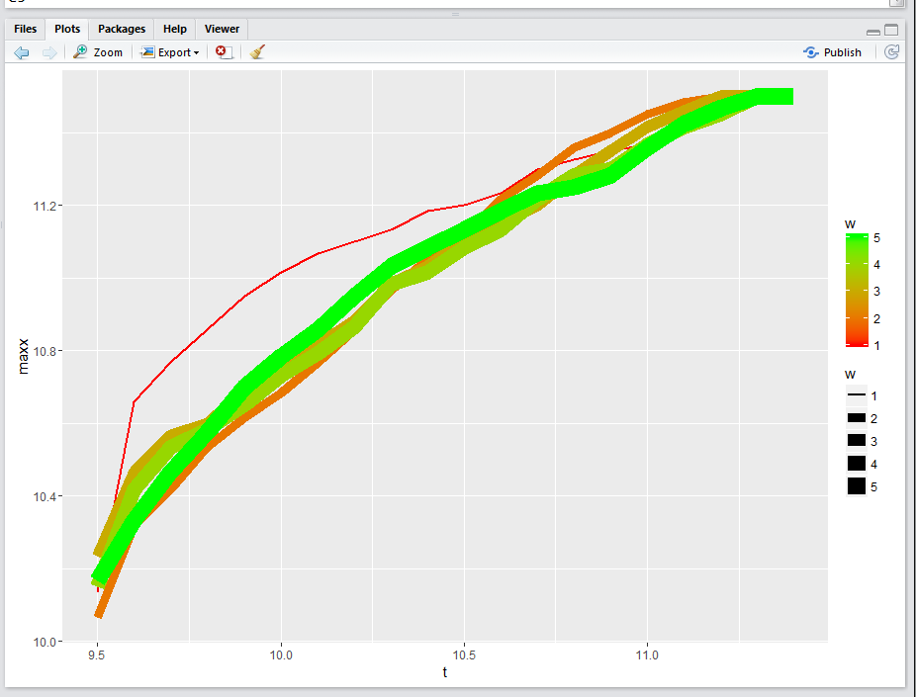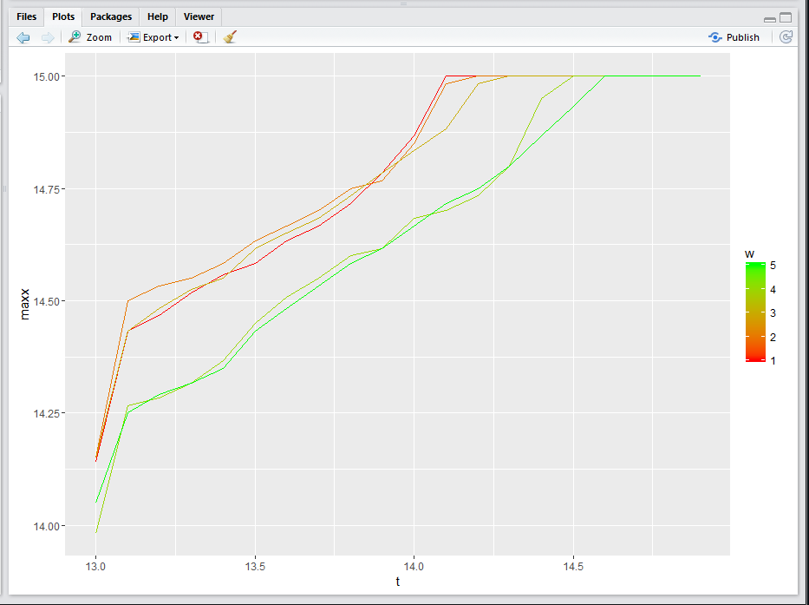

**Review 2016Aug22**

Atrocious day.

First, China was closed on this day. Markets were at 5-7% premium in HK in anticipation of China's comeback. On the next day, the ETFs would drop by 3-5% because China only moved about 3%. Apparently the greed was the driving force behind the rally of this day. Markets oscillate above and below value, and given this size of premium it was not really rational to buy into this rally. However, since the trend was clearly bullish shorting this trend would be difficult on the day per se. Why daily K candles are useful because it provides a cooling off period. People come to their senses and start reflection, which was not possible on the day itself. Also, Wednesday is a traditionally strong day which consistently outperforms anything other than Tuesday.

**Review 2017713**

This keeps getting reviewed for some reasons. Probably because the trading was terrible. Lost money on the initial trades and more trades kept being put on in the same wrong direction.

China was on national holidays this period and HK was open on this day.

The trading is bad because you are not supposed to short in a rising market. At the time of this review, I was managing about 4m RMB in assets. I have been up in trading futures every single month this year. The key to trading these futures is first, treat them like an equity and play long term, with trading adjustments in between instead of going in and out without thinking. Long term view needs to be established and you must trade around the position with an intraday perspective. Time horizon needs to be over a period of time, not as short as minutes or hours but days. The only trustworthy principles are day to day negative serialial correlation and general pm strength. Any intraday move is not advantageous.